ML and DS Internship Practical

Month 1 – Python Fundamentals

ATM Simulation System

Submitted By:
Saniya Shaikh

Submitted To: -
Mr. Farhan Memon (Groot Technology)
Technology Used: Python
Development Environment: Visual Studio Code

Table of Contents
Sr. No. | Contents | Page No.
1 | Objective | 3
2 | Introduction | 3
3 | Features | 3
4 | Concepts Used | 4
5 | Project Workflow | 5
6 | Learning Outcomes | 5
7 | Advantages | 6
8 | Limitations | 6
9 | Testing Report | 6
10 | Screenshots | 8
11 | Conclusion | 9
12 | GitHub Repository Link | 10

1 Objective: -
The objective of this project is to develop a console-based ATM Simulation System using Python. The application simulates basic banking operations such as deposit, withdrawal, balance inquiry, and transaction history. This project helps in understanding conditional statements, functions, and exception handling.
2 Introduction: -
An Automated Teller Machine (ATM) allows users to perform banking transactions without visiting a bank branch. This ATM Simulation project provides a simplified version of ATM functionality through a menu-driven interface. Users can deposit money, withdraw money, check their account balance, and view transaction history.
The project is designed to strengthen programming skills and demonstrate the practical implementation of Python fundamentals.
3 Features: -
1. Deposit Money
Users can deposit a specified amount into their account. The account balance is updated automatically after a successful transaction.
2. Withdraw Money
Users can withdraw money from their account. The system checks whether sufficient balance is available before processing the withdrawal.
3. Balance Inquiry
Users can view their current account balance at any time.
4. Transaction History
The system stores and displays all successful deposits and withdrawals performed during program execution.
5. Menu-Driven Interface
A user-friendly menu allows users to select different banking operations easily.
6. Exception Handling
Exception handling is used to manage invalid user input and prevent program crashes.

4 Concepts Used: -

Variables
- Used to store balance, transaction details, and user choices.
Data Types
- Integer
- Float
- String
- List
Conditional Statements
- Used for decision-making:
- Checking sufficient balance
- Validating user input
- Processing menu choices
Loops
- A while loop is used to repeatedly display the ATM menu until the user exits
Functions
- Separate functions are used for:
- Deposit
- Withdraw
- Balance Inquiry
- Transaction History
Lists
- Transaction records are stored in a list for future reference.
Exception Handling
- Used to handle:
- Invalid numeric input
- Unexpected user entries
- Runtime errors
- Delete → Delete Student Record
5 Project Workflow: -
- Start the ATM Simulation program.
- Display the main menu.
- User selects an operation.
- System processes the selected operation.
- Balance and transaction history are updated.
- Menu is displayed again.
- User exits the application.
6 Learning Outcomes: -
Through this project, the following concepts were learned:
- Conditional Statements
- Functions
- Loops
- Lists
- Exception Handling
- Input Validation
- Menu-Driven Programming
- Transaction Management
- Problem Solving Skills
7 Advantages: -
- Easy to use
- Beginner-friendly
- Demonstrates banking transaction logic
- Improves programming skills
- Enhances logical thinking and decision-making
8 Limitations: -
- Data is stored temporarily during program execution.
- Transactions are not saved permanently.
- No database integration.
9 Testing Report: -
Test ID | Test Description | Test Input | Expected Result | Status
TC01 | Deposit valid amount | 500 | Amount deposited successfully | Pass
TC02 | Deposit large amount | 10000 | Amount deposited successfully | Pass
TC03 | Deposit zero amount | 0 | Validation message displayed | Pass
TC04 | Deposit negative amount | -500 | Error message displayed | Pass
TC05 | Withdraw valid amount | 200 | Amount withdrawn successfully | Pass
TC06 | Withdraw amount equal to balance | Full Balance | Withdrawal successful | Pass
TC07 | Withdraw amount greater than balance | Balance + 100 | Insufficient balance message displayed | Pass
TC08 | Withdraw negative amount | -100 | Error message displayed | Pass
TC09 | Withdraw zero amount | 0 | Validation message displayed | Pass
TC10 | Check account balance | Balance Inquiry | Current balance displayed | Pass
TC11 | View transaction history after deposit | Deposit Transaction | Transaction displayed | Pass
TC12 | View transaction history after withdrawal | Withdrawal Transaction | Transaction displayed | Pass
TC13 | View empty transaction history | No Transactions | No transaction found message display | Pass
TC14 | Enter invalid menu choice | 9 | Invalid choice message displayed | Pass
TC15 | Enter alphabet instead of amount | abc | Exception handled successfully | Pass
TC16 | Enter special characters as amount | @#$ | Exception handled successfully | Pass
TC17 | Perform multiple deposits | Multiple Deposits | Balance updated correctly | Pass
TC18 | Perform multiple withdrawals | Multiple Withdrawals | Balance updated correctly | Pass
TC19 | Check balance after multiple transactions | Mixed Transactions | Correct balance displayed | Pass
TC20 | Exit application | Exit Option | Program terminated successfully | Pass

10 Screenshot: -
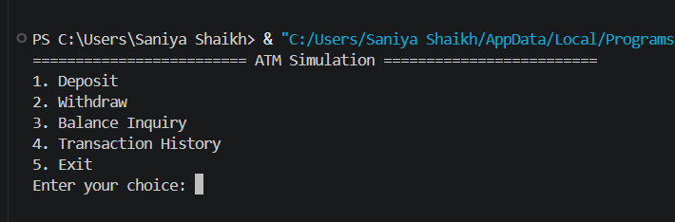
  - Menu Options

  - Enter choice and deposit amount
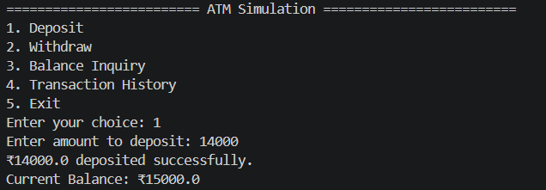

  - Withdraw money
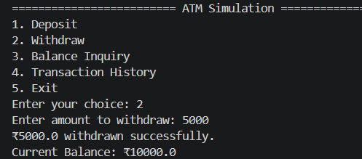

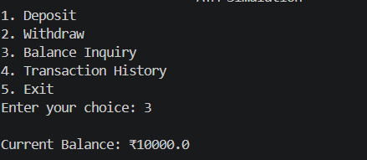
  - Balance Inquiry

  - Transaction History
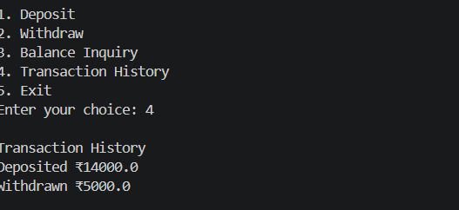

  - Exit
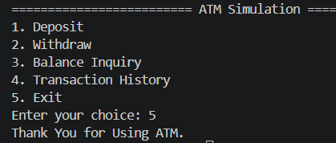

11 Conclusion: -
The ATM Simulation System successfully demonstrates the implementation of Python programming concepts such as conditional statements, functions, loops, lists, and exception handling. The project provides practical experience in handling banking transactions and managing account balances through a menu-driven application. It serves as a strong foundation for developing more advanced financial and banking applications in the future.
12 GitHub Repository Link: -
https://github.com/saniya2698/ATM-Simulation-System-/tree/main

